
Project Name: Property Management System
Client Name: Noida Authority
Commercial Department

North Shore Technologies Pvt. Ltd.
_________________________________________________________________
Logix Techno Park ♦ Sector 127 ♦ Noida – 201301 ♦ India
Phone : (120) – 404 3401

Contents

Introduction 5
Purpose & Objectives 5
User Classes and Characteristics 5
Commercial – Complete Process 7
1. Allotment Process 8
1.1 Scheme Creation 9
1.2 Adding property(s) to the scheme 9
1.3 Scheme Notification to Public 9
1.4 Submission of the Bids to Authority 9
1.5 View & Rejection of the tenders 9
1.6 Adding Qualified Customer details 9
1.7 Approval for Successful Applicants 9
1.8 Allotment Letter Issuance 9
1.9 Business Rules for Allotment 10
2. Request for Lease Deed Execution 12
2.1 Payment of Allotment Money 13
2.2 Failure to pay allotment money 13
2.3 Issuance of Checklist 13
2.4 Time period for Lease Deed 13
2.5 Lease Deed Executed 13
2.6 Initiation of Lease Rent 13
2.7 Business Rules for Lease deed 13
3. Request for Possession Certificate 15
3.1 Customer Submits Application 16
3.2 Approval from engineering department 16
3.3 Re-Adjustment of Change in Area 16
3.4 Business Rules for Possession 16
4. Request of Completion Certificate 17
4.1 Customer submits the Completion Certificate Request 17
4.2 Validation from Planning & Account Department 18
4.3 Business Rules for Completion Certificate 18
5. Request for Functional Letter 19
5.1 Customer submits the Functional Request 19
5.2 Validation from Account Department 20
5.3 Approval from Manager 20
5.4 Functional Letter Issuance 20
5.5 Business Rule for Functional 20
6. Request for Transfer of Property 22
6.1 Customer submits the application 22
6.2 Validation from Accounts & Legal Department 22
6.3 Customer pays transfer charges 23
6.4 Approval from Manager 23
6.5 Transfer Deed Executed 23
6.6 Business Rule for Transfer of Property 23
7. Request for Issue of Mutation (Substitution) 24
7.1 Customer submits the application 25
7.2 Validation of documents 25
7.3 Approval from manager 25
7.4 Business Rules for Mutation 25
8. Request for Mortgage 26
8.1 Customer submits the mortgage request 26
8.2 Validation from Account department 26
8.3 Approval from Manager 27
8.4 Mortgage Letter Issuance 27
8.5 Business Rules for Mortgage 27
9. Request for Change in Constitution (CIC/CIS/CIN/COD) 29
9.1 Customer submits application 30
9.2 Validation from Account department 30
9.3 Approval from manager 30
9.4 CIC Letter Issuance 30
9.5 Business Rules for CIC 30
10 Request for Rent Permission 32
10.1 Customer submits application 32
10.2 Validation from Account department 32
10.3 Approval from manager 33
11 Request for Sublease 34
11.1 Customer submits application 34
11.2 Validation from Account department 34
11.3 Approval from manager 35
11.4 Business Rules for Sublease 35
12 Payment Schedule Logic for Commercial Department 36
12.1 Payment Schedule Formulae 36
12.2 Dues Calculation 37
12.3 Miscellaneous 39

Introduction

New Okhla Commercial Development Authority plays a significant role in building the world class infrastructure which is situated in the vicinity of Delhi NCR. It plays a significant role in development of infrastructure within its defined geographical boundaries. The development of the infrastructure includes the Commercial development, Commercial development, Commercial development, Residential/Commercial development, Group commercial development, roads and transport infrastructure development and horticulture development. Considering the potential growth rate of NOIDA, an optimized business processes are needed to serve the customers with different establishments like commercial, commercial, residential, commercial and commercial.
Currently the property management system in NOIDA is being managed on the web builder database. The business processes for different kinds of service delivery is effective but lacking in the efficiency. In the current working system the technical framework is old and almost obsolete. The data management system is in the physical form and important wing of the authority like planning, engineering has no effective system to manage their activities. There is a complete lack of interface at authority level for internal communication with departments. The existing web builder system shall also run for certain time as determined by the Authority during the transition period. Effective business processes are required across the different entities\departments of Noida to attain the desired level of efficiency and ensure better services to the customers\end customers. The need is to bring an integrated database which allows the work processes to be performed efficiently and introducing a tool or dashboard for higher management/officers to monitor the activities.

Purpose & Objectives

The overall purpose of this project is to build up an integrated system which will bring the efficiency to the work flow processes. The system would primarily facilitate access on the web browser, e-enabling of various processes across and allow adoption of comprehensive approach towards gaining the efficiency. The system would enable the Noida staff officials, working assistants and end customers to access the integrated data from different business processes. It would share the relevant information across the different departments which will help in making operational as well as strategical decision.

User Classes and Characteristics

The functioning of the department is classified on the basis of the below specified roles under the commercial department for better understandability:
- Manager Level
The manager is a key role whose prime responsibility is to validate the requests received from the assistant level. After the successful validation of the request, the manager level passes on the approval or the cancellation.
The manager will approve/reject the request received from assistant after getting the direction from the below departments:
  - Account Department
  - Legal Department
  - Engineering Department
  - Planning Department

- Assistant Level
The assistant is responsible for all the activities of commercial department and also involved in processing all the property request received from the customer. He is also responsible for maintaining the important letters associated to the allottee properties.

- Customer Level
The customer is involved in each activity of the property process model and is responsible for submitting the requests along with required documents to the assistant for the initiation of the same.

Commercial – Complete Process

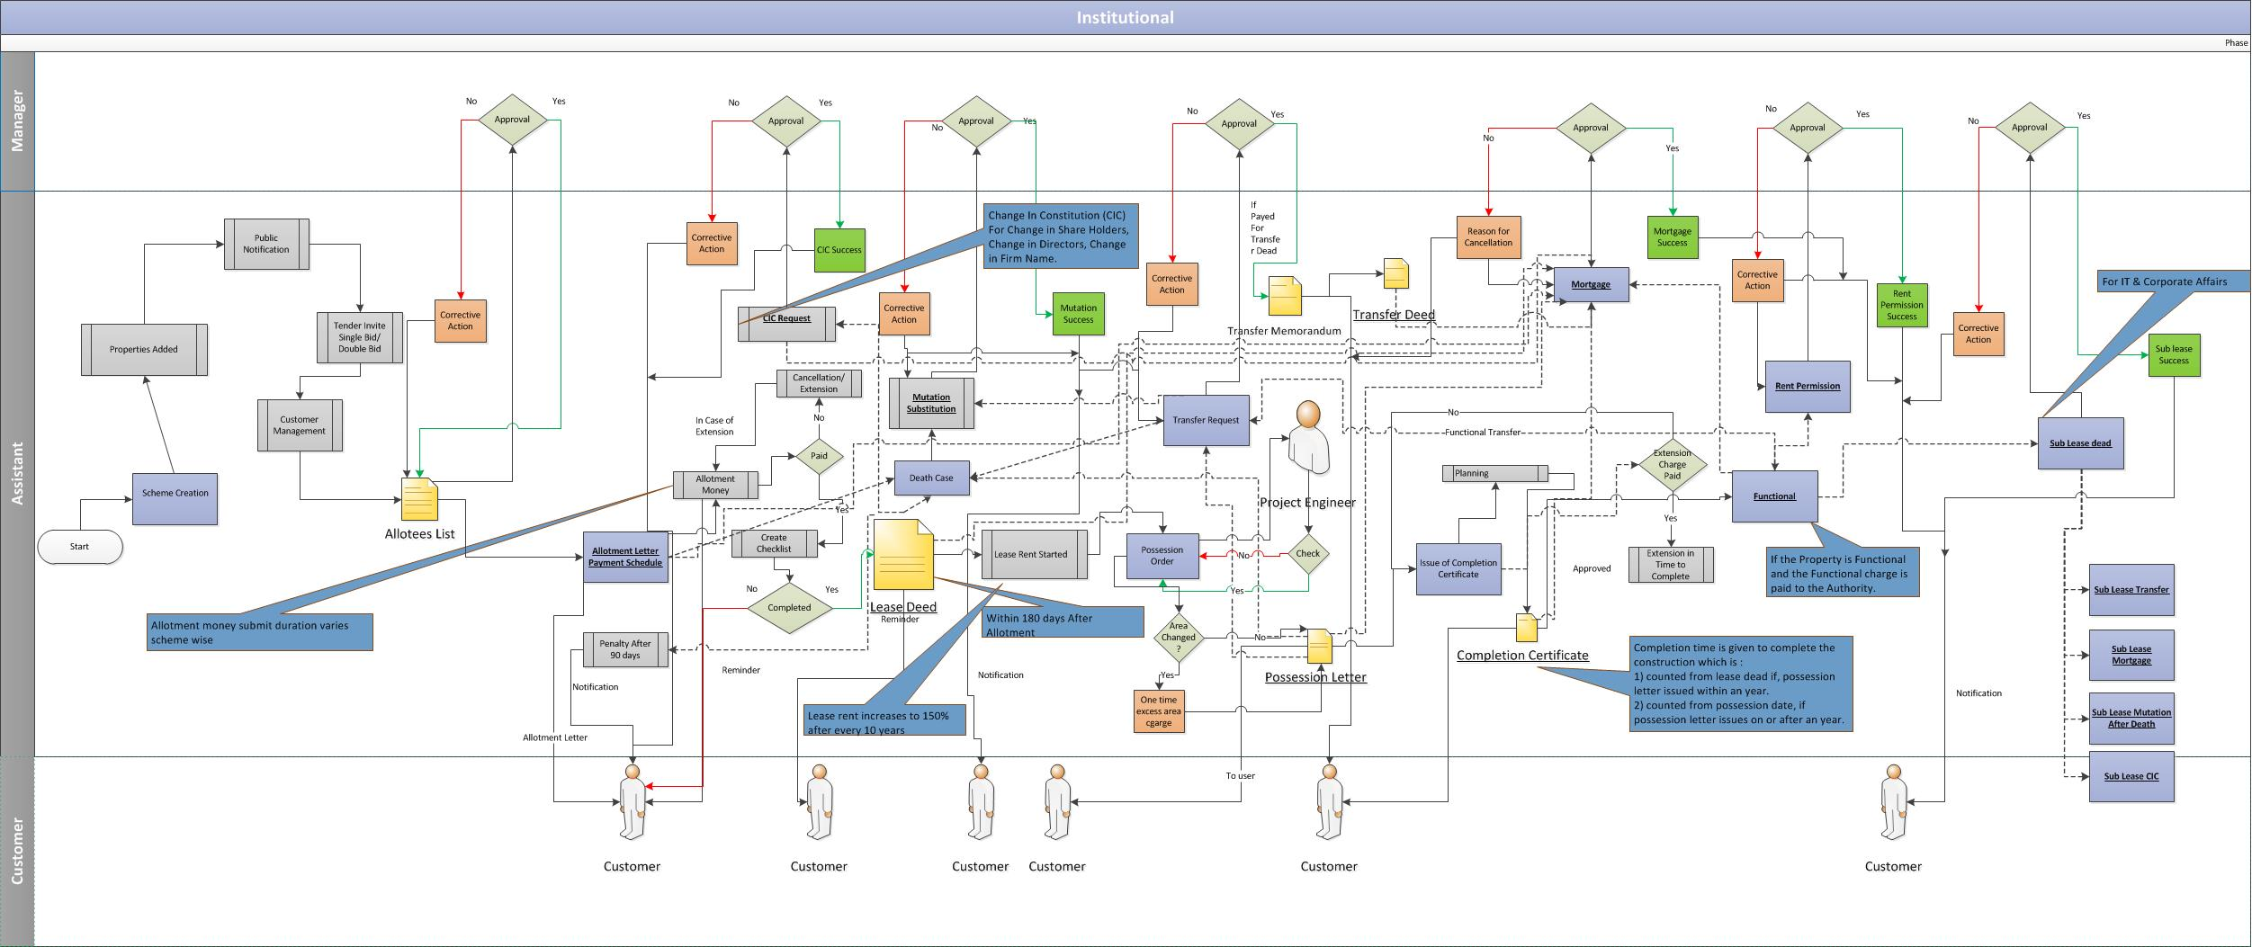

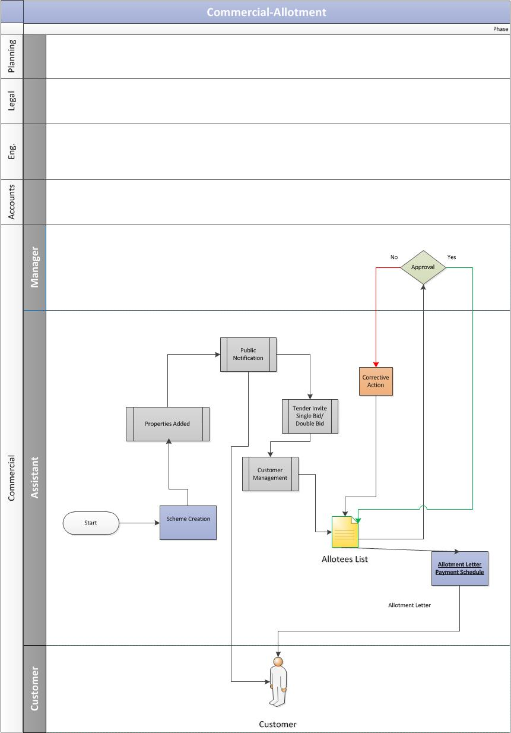
Allotment Process

Scheme Creation
- The foremost step is classification and the creation of the schemes looking at the demographic region for the Commercial sectors at Noida.

Adding property(s) to the scheme
    - The assistant adds the property details under the newly created scheme for following type and property details are shared by the planning department.
- Built up shops
- Actual user plots
- Builder plots

Scheme Notification to Public
    - Post adding the properties to the respective scheme(s), the authority invites sealed tender for allotment of properties under specific scheme to the public.
    - The tender based scheme are divided into two types:
- Single Bid Scheme (only Financial)
- Double Bid Scheme (First Technical bid then financial)
    - This public notification contains the detailed information about the commercial scheme.

Submission of the Bids to Authority
    - The bidders submits the tender application with separate demand draft and required documents in the tender box available in the commercial department.

View & Rejection of the tenders
    - The tenderers are invited, when the sealed tenders are to be opened by the constituted officer.
    - For Single Bid system, the financial validation is done for the documents which are submitted.
    - For Double Bid System, the technical evaluation is done by the manager and then financial. However the financial bid will only be opened if the bidder found technically qualified.
    - The tenders which incomplete are rejected.

Adding Qualified Customer details
    - The assistant would add the details for all the applicants, received from the commercial department, into their respective system for tender based schemes. The assistant adds details for all the applicants into the respective system for the both single bid and double bid system.

Approval for Successful Applicants
    - Post customer management, the applicants are selected:
      - For Single Bid (Shop)
        - The list of successful applicants, after evaluation of the financial quote, is prepared and sent further to the manager for his approval.
      - For Double Bid (Plot)
        - The list of successful applicants, after the evaluation of technical and financial quote, is prepared and sent further to the manager for his approval.

Allotment Letter Issuance
    - Post approval of the allottee list from the manager, the allotment is done for all the successful applicants. The allotment letter along with payment schedule will be issued to the allottee.

Business Rules for Allotment
- Any person, a registered partnership firm, Pvt. /Public Ltd. Company may submit tender for one or more than one plots/built up shops. A separate application shall be required to be submitted for each plot/built up shop.
- In case of partnership firm, all partners are required to sign the tender form. In case of Pvt. /Public Ltd. Company, the board resolution authorizing the applicant to sign on behalf of the Company
- In case of Partnership firm, a certified copy of partnership deed along with certificate issued by Registrar of Firms shall also be required with the tender form.
- Incomplete tender shall be summarily rejected.
- Any change in the name of the intending tenderer will not be allowed under any circumstances.
- The tenderer should be competent to submit the tender and enter into contract in law.
Mode of Allotment
.
- If due to any "FORCE MAJEURE" or circumstances, beyond Authority's control, the Authority is unable to make allotment or deliver possession of allotted plot, entire earnest money and the deposits depending on state of allotment shall be refunded without interest.
- Tenderer is informed about acceptance of tender in writing through allotment letter. In case more than one tender of same amount is received against the plot/shop, fresh tenders shall be invited from the tenderer by the committee.
- Allottee/Lessees/Sub-lessees/Transferee after 15.06.2001, are not eligible for any preferential allotment of residential plot/house under various schemes of the Authority. However, this condition shall not apply in the case of transfer in blood relation.
- The allotment is made on “As Is Where Is Basis”. In case of variation in the dimensions shown in the brochure and at the site, Allottee will accept the variation and in case of increased/decreased in the plot area, payment shall be adjusted/demanded as proportionate to tender rate.

For Shops
- After acceptance of the tender, tenderer will be informed of such acceptance in writing through allotment letter and he shall pay 20% of the premium within 30 days thereof.
- If 20% amount is not paid within prescribed 30 days, the earnest money will be forfeited. No extension of time shall be granted for deposit of this amount under any circumstances.
- Balance 80% of the premium will be deposited by the allottee in 16 equal half yearly instalments along with interest @ 12% p.a. Or as amended by the Authority from time to time on outstanding premium compounded half yearly. First such instalment will fall due within six months from the date of allotment. The allottee shall be required to deposit the instalment and interest on or before the given date. No challan shall be issued for payment of instalment and interest.
- If the allottee fails to pay instalments within due dates, allotment will be cancelled and amount equivalent to 30% of premium will be forfeited in favour of the Authority. However, in exceptional circumstances, extension for deposit of instalment/interest will be granted at the sole discretion of Chief Executive Officer or any other officer authorized by him but it will be subject to payment of interest @ 15% p.a. or as amended by the Authority from time to time compounded every half yearly on defaulted amount for delayed period.

For Plots
- After acceptance of the tender, tenderer will be informed of such acceptance in writing through allotment letter and he shall pay 25% of the premium within 30 days thereof.
- If 25% amount is not paid within prescribed 30 days, the earnest money will be forfeited. No extension of time shall be granted for deposit of this amount under any circumstances.
- Balance 75% of the premium will be deposited by the allottee in 16 equal half yearly instalments/ as per brochure of the scheme alongwith interest @ 12% p.a. or as amended by the Authority from time to time on outstanding premium compounded half yearly. First such instalment will fall due within six months from the date of allotment. The allottee shall be required to deposit the instalment and interest on or before the given date. No challan shall be issued for payment of instalments and interest.
- If the allottee fails to pay instalments within due dates, allotment will be cancelled and amount equivalent to 30% of premium will be forfeited in favor of the Authority. However, in exceptional circumstances, extension for deposit of instalment/interest will be granted at the sole discretion of Chief Executive Officer or any other officer authorized by him but it will be subject to payment of interest @ 15% p.a. or as amended by the Authority from time to time compounded every half yearly on defaulted amount for delayed period.

Request for Lease Deed Execution

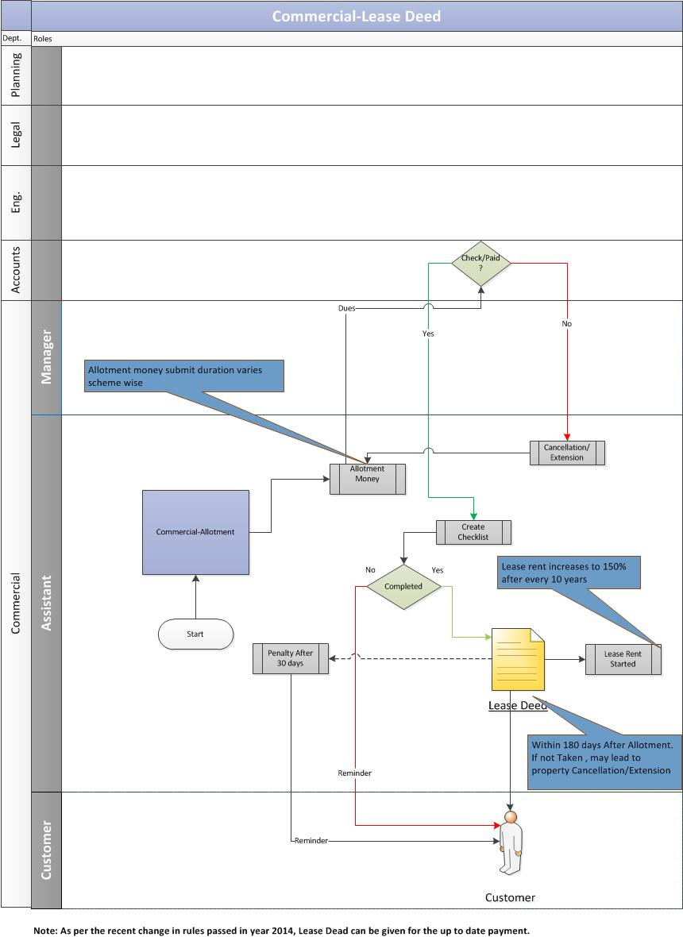

Payment of Allotment Money
    - Post the allotment process, the allotment money needs to be paid by the Customer to the authority as per timeframe specified in the scheme (Time period for submission of allotment money varies scheme wise). Allotment money is calculated as 30% of the total cost.

Failure to pay allotment money
    - If the allotment money is not submitted within timeframe specified as per tender scheme to authority then it may lead to below scenarios:
      - Case of Extension: If the customer is unable to submit the allotment money within timeframe specified as per the scheme after allotment letter is issued, then he/she is liable to pay the penalty charges for extension
      - Case of Cancellation: If the customer is unable to submit the allotment money within timeframe specified as per the scheme after allotment letter is issued, then it may result in cancellation of allotment.

Issuance of Checklist
    - After allotment money has been received by the authority, the assistant would issue a checklist that has the list of important documents which are required to be verified for the lease deed. In case the allotment money.

Time period for Lease Deed
    - After the issuance of checklist, the customer would be eligible to get the lease deed executed for the allotted property within 180 days after the allotment. The customer would be liable to pay the penalty if he misses the respective time period of 30 days.

Lease Deed Executed
    - In case of timely filing the request, the lease deed is executed by the authority to the customer and one copy of the lease deed is sent to the commercial department for maintaining their records.

Initiation of Lease Rent
    - After the successful completion of the lease deed, the lease rent starts.

Business Rules for Lease deed
- The successful tenderer/allottee will have to execute lease deed and take over possession of the plot/shop within 120 days from the date of allotment after completing of formalities as indicated in the allotment letter and check list. In case of allottee's failure to do so within the above stipulated period, the allotment of plot will be cancelled & the money deposited shall be forfeited as per terms and conditions of the allotment/brochure of the scheme. The interest and other penalties, if deposited, shall also be forfeited. However, in exceptional circumstances the extension for execution of lease deed may be permitted. But these extension will be subject to payment of penalty @ 5% of total premium annually which will be calculated on day to day basis. After execution of lease deed, allottee will take over the possession of plot within 15 days from the concerned project engineer. The date of execution lease deed shall be as the date of handed over of actual physical position, notwithstanding any other claim. The cost and expenses of preparation, stamping and registering the lease deed and its copies and all other incidental expenses shall be paid by the allottee.

Lease Rent
- In addition to tendered amount, the allottee/lessee shall have to pay yearly ground rent/lease rent in advance in the manner indicated below:-
- The ground/lease rent shall be charged @ 2.5% p.a. of the total premium of the plot for the first 10 years from the stipulated date of execution of lease deed.
- The ground rent / lease rent in the cases of builders plot shall be charged @ Re 1/- per sqm. per year for first three years from the stipulated date of execution of lease deed and 2.5% per annum for rest of the seven years of first ten years.
- The ground/lease rent shall be charged @ 1% p.a. of the total premium of the shop for the first 10 years from the stipulated date of execution of lease deed.
- The ground rent/lease rent of the plot and built up shop shall be enhanced after expiry of every 10 years from the stipulated date of execution of lease deed. This enhancement will be 50% of lease rent/ ground rent last thus fixed.
OR
- The lessee has the option to pay 11 years lease rent @ 2.5% p.a. for the plot and @ 1% for built-up shops, of the total premium as ONE TIME LEASE RENT. Thereafter no lease rent shall be payable for the entire period of lease.

Request for Possession Certificate

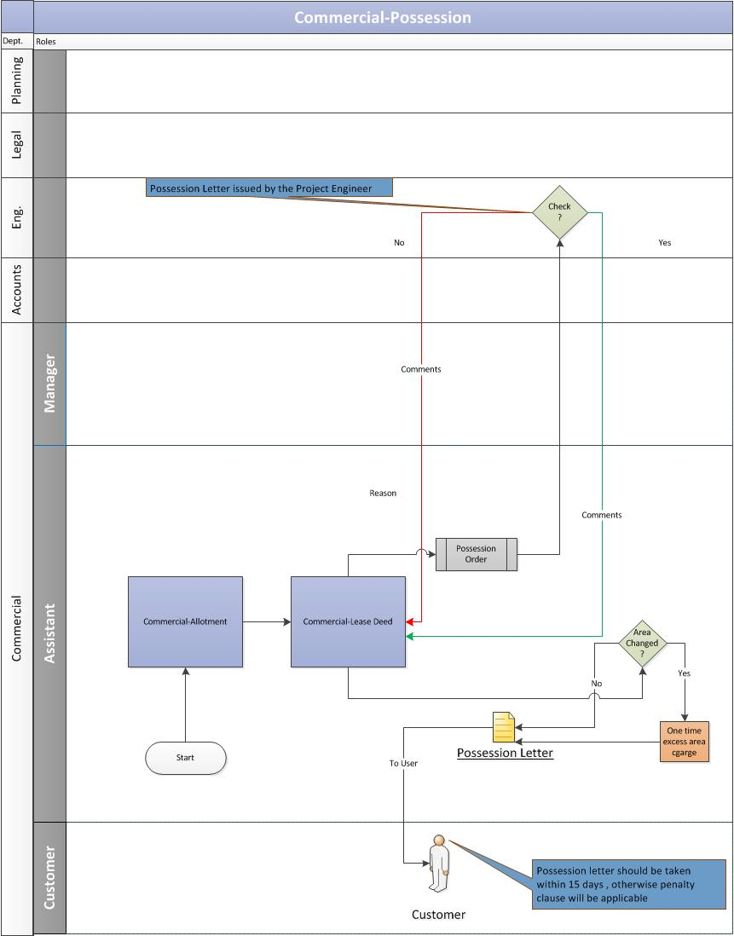

Customer Submits Application
    - The customer duly submits the application along with the required documents to get the possession certificate for the property.

Approval from engineering department
    - Assistant would validate the documents of the allotted property and send the possession order to the project engineer for further action:
      - If the project engineer does not approve the possession order, then he/she is required to send the valid reason to the assistant.
      - If the project engineer approves the possession order, the assistant will issue the possession letter to the customer.

Re-Adjustment of Change in Area
    - If there is a change in the property area during the possession phase, the assistant would readjust the area amount and would notify the same to the customer.
      - In case of increase in area, the assistant would calculate the excess amount and ask the customer to pay the same as a one-time payment. Once the customer pays the one-time excess amount, he will be issued the possession certificate.
      - In case of decrease in area, the assistant would the re-adjust the amount and reschedule the installments of the customer.

Business Rules for Possession
- It is mandatory for the lease deed to be executed in order for the possession certificate to be issued.
- Possession certificate can only be issued if the lease deed is executed.
- As per the recent regulation passed in year 2014, possession certificate can be applied if the transferor has paid all his/her dues and once the Possession Certificate is issued, the remaining number of payments will be paid by the transferee.

Request of Completion Certificate

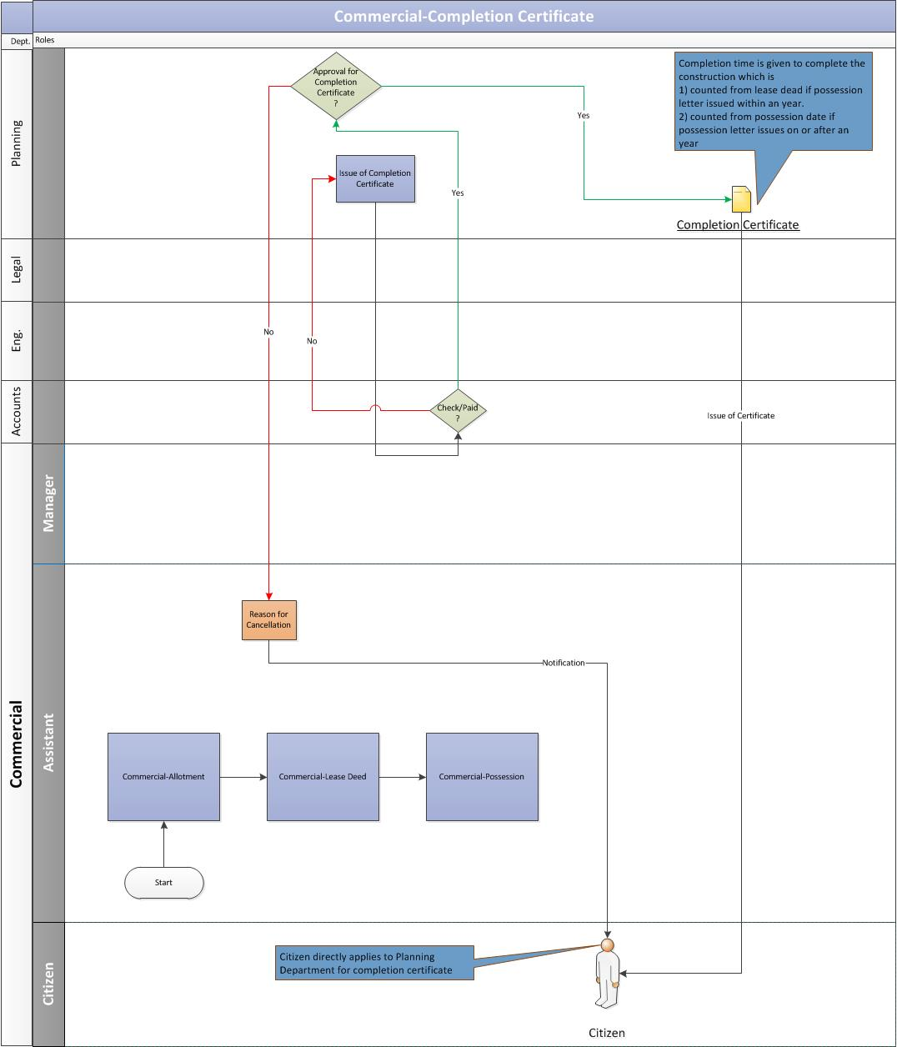

Customer submits the Completion Certificate Request
    - The allottee duly submits the completion certificate request along with the required documents to the concerned department at Noida Authority.

Validation from Planning & Account Department
    - The Planning department receives the completion certificate request and would validate the allottee’s documents.
    - The planning department verifies with the accounts department whether the customer has paid for the completion charges:
      - If the completion charges are paid by the customer and the account department gives a go-ahead then the Planning department would issue the completion certificate to the customer.
      - If the completion charges are not paid by the customer then the Planning department would not issue the completion certificate to the customer.

Business Rules for Completion Certificate
- It is mandatory to get the completion certificate issued after lease deed is executed for property within time span of 2 years.
- If the completion certificate is not issued then extension charges will applied up to date.
- It is mandatory to have the completion certificate before the transfer of property.

Request for Functional Letter

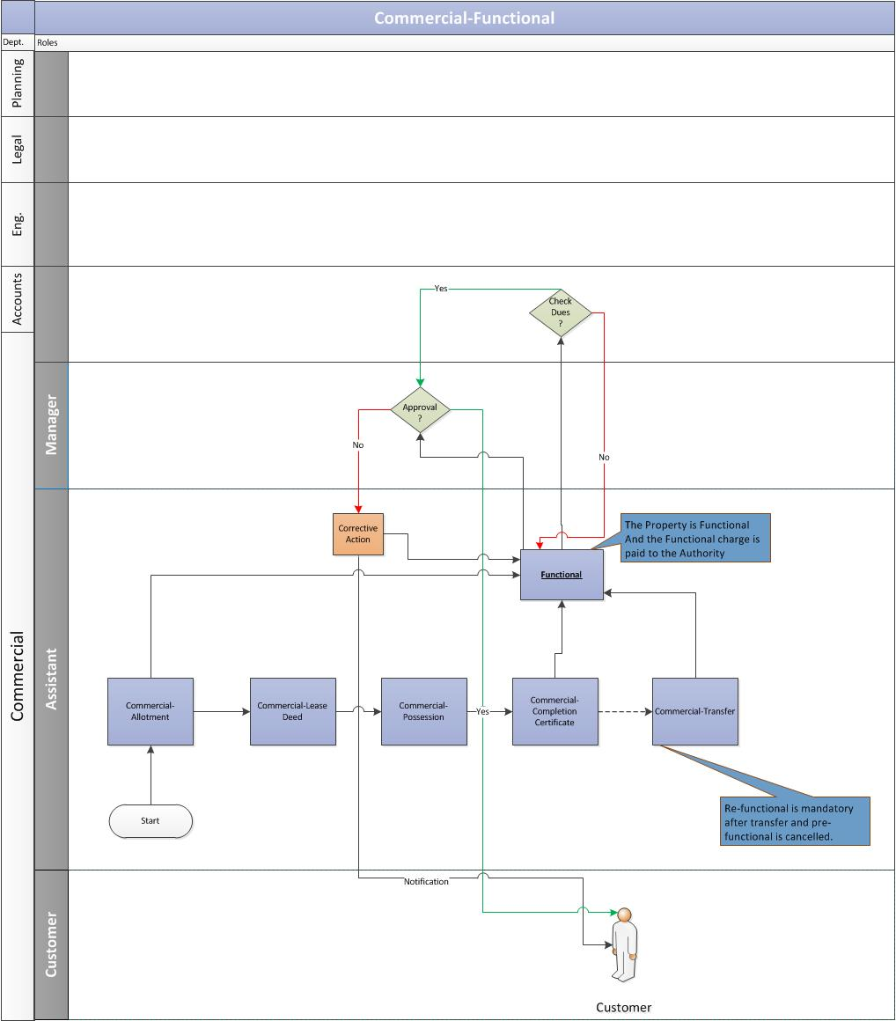

Customer submits the Functional Request
    - The allottee duly submits the Functional letter request along with the required documents to the concerned department at Noida Authority.

Validation from Account Department
    - The assistant receives the functional request and would send the same to account department to validate the allottee’s account details for any pending dues.
    - The account department would verify the allottee’s account details. In case of no pending dues, the account department would issue a No Dues certificate.

Approval from Manager
    - After receiving the confirmation from accounts department, the assistant would send the Functional request to the manager for his approval.

Functional Letter Issuance
    - Once the manager approves the functional request, the assistant would issue the Functional letter to the customer.
    - In case any previous dues exists, the assistant would notify the customer to clear the previous dues first before applying for the functional letter.

Business Rule for Functional
- The allottees of commercial properties are required to make their establishment functional as per terms and conditions of the allotment. The allottee/lessee/sub-lessee/transferee was require to submit the following documents for declaration of a commercial establishment functional. Attested copy of one of following documents:
- Electric Meter Sealing Certificate issued by UPSEB.
- Sales Tax Registration Certificate.
- A certificate from MLA/MP/Gazetted Officer/Bank Manager certifying the commercial establishment functional.
- As per decision taken by authority, following time was allowed for making the unit functional:-
- Stipulated time period for functioning on built up premises 2 years
- Stipulated time period for construction of building and functioning 3 years
on plots
Note: Time may vary in future
- After expiry of above period extension charges shall be payable as per prevailing policy, however, at present the rates are as under:-
- First year - 5% of the total allotment cost of plot/shop
- Second year - 7.5% of the total allotment cost of plot/shop
- Third year - 10% of the total allotment cost of plot/shop
- Fourth year - 15% of the total allotment cost of plot/shop
- Fifth year and thereafter every year - 20% of the total allotment
cost of plot/shop
- The allottees who have already deposited extension charges as per then prevailing policy shall not be effected. Extension permission as per above can be granted for minimum one month period.
- In case of transfer of Commercial plot/premises, transferee shall get one year period for construction of premises/making the unit functional without payment of extension charges. Thereafter, extension charges shall be applicable considering the expiry of one year period from the date of transfer memorandum. The free period of one year in transfer cases shall be allowed both in functional and non-functional cases. However in non-functional cases the transferor shall be required to pay up to date extension charges till the date of transfer.
- In case of property declared functional and transferred within blood relation i.e. father/mother, husband/wife, son/daughter, the transferee shall not again require to submit documents with regards to functionality of property and the property shall deemed to be functional in favor of transferee w.e.f. the date of issue of transfer memorandum.

Request for Transfer of Property

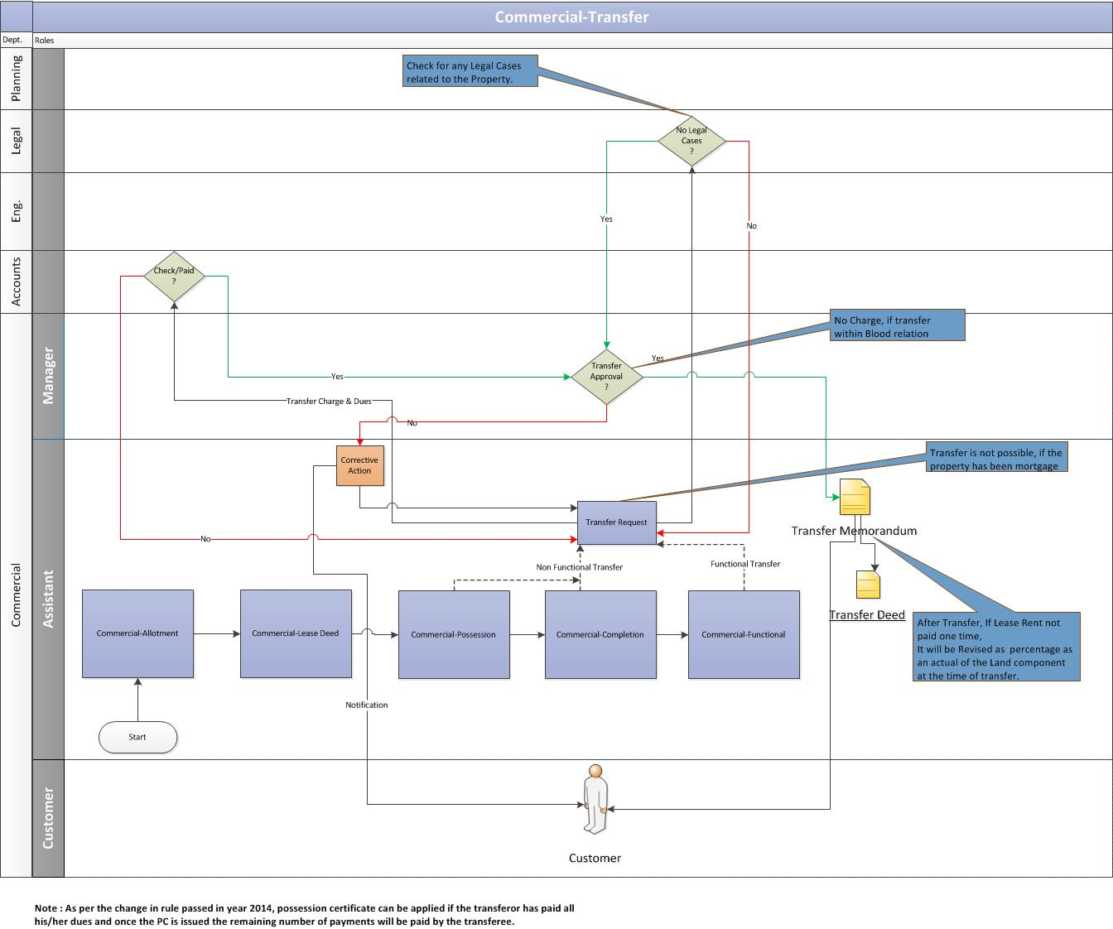

Customer submits the application
    - The transferor (allottee) of the property submits the transfer application request to the respective department at the Noida Authority.

Validation from Accounts & Legal Department
    - Assistant would receive the transfer request and validate the allottee’s account details and litigation details to the concerned departments.
      - The account department would verify the allottee’s account details. In case of no pending dues, the account department would issue a No Dues certificate.
      - The legal department would verify if there are any legal cases on the property. In case of no legal cases, the legal department would issue a clearance certificate.

Customer pays transfer charges
    - Post verification from the accounts and legal departments, the assistant would ask the customer to pay the transfer charges.
    - The customer pays the transfer charges and updates the same to the authority.
    - The assistant verifies the transfer payment details with the account department.
    - After receiving the payment confirmation from accounts, the assistant would send the transfer request to the manager for his approval.

Approval from Manager
    - Once the manager approves the transfer request, the assistant would issue the Transfer memorandum to the customer.

Transfer Deed Executed
    - Based on the transfer memorandum, the transfer deed will be executed.

Business Rule for Transfer of Property
- The cases, where cancellation has been effected, are not eligible for transfer.
- Only bonafide allottee/lessees/transferees/sub-lessee are eligible to transfer commercial property allotted/transferred to them.
- The transfer application form should be duly filled in along with the NOC’s from various department i.e. P.E. (Jal), AO(Comm.). (all original documents i.e. allotment letter, possession letter as well as subsequent legal documents are required to be submitted along with transfer application form).
- Transfer application should pay the transfer processing fee.
- That the lessee may be entitled to sell, transfer, assign the property after payment of up to date instalment(s), interest and lease rent. The lessee will also be required to pay the transfer charges as per policy.
- The transferee undertakes to put to use the plot/shop for the original permissible use only.
- The lessee shall pay transfer charges prevailing at the time of transfer.
- The transfer charges shall be as per policy prevailing on the date of transfer application.
- Transferor and transferee should severally and/or jointly satisfy themselves about the over-dues/dues position from the Accounts Officer (Commercial) of the Authority.
- Once transfer is approved and Transfer Memorandum is issued, all the assets and or liabilities against the commercial property (is) would pass on the transferee.
- Lease rent will be charged @ prevailing rate at the time of transfer subject to enhancement as envisaged in lease deed/ transfer deed/ transfer memorandum. However, delayed payments in this regard are subject to payment of interest as per rules of the Authority prevailing from time to time.
- Transfer of commercial properties by original allottee/transferee in blood relation i.e. in favour of father/mother/husband/wife/son/daughter and vise-versa would be allowed without charges, subject to payment of transfer processing fee of Rs.1,000/-.
Note: Transfer Fee may vary in future.
- Transferor and Transferee would execute and register the Transfer Deed within 90 days from the date of Transfer Memorandum. In case the possession of property is given after execution of HPTA than allotee is to revoke the HPTA and proposed transferee shall execute lease deed. In case of failure to execute the transfer deed or lease deed as the case may be, penalty shall be charged as per terms and conditions of allotment/transfer memorandum.

Request for Issue of Mutation (Substitution)

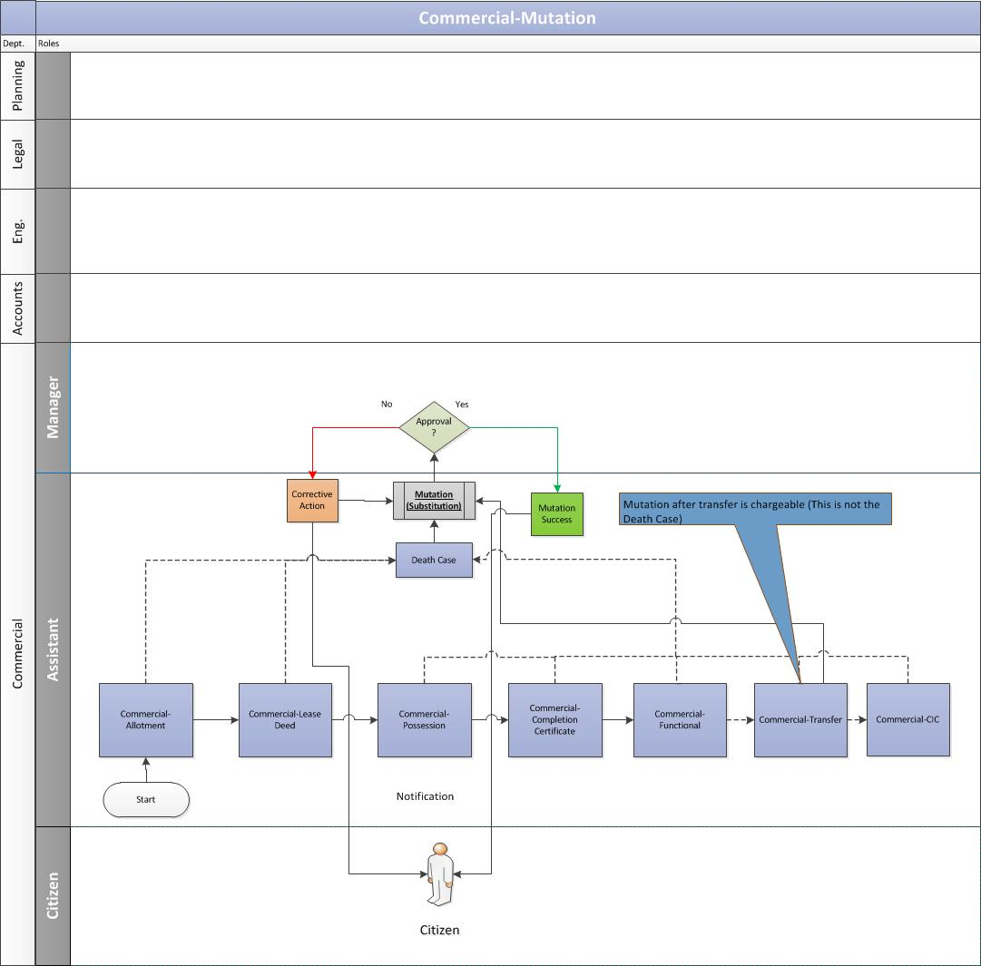

Customer submits the application
    - If the owner of the property dies then the transferee/beneficiary of the property submit the application along with required documents at the commercial department of the authority.

Validation of documents
    - The assistant receives the mutation (substitution) request and validate the application and documents attached to it.

Approval from manager
    - If the papers are in place, the assistant would send the mutation request to the manager for his approval:
      - If the manager approves the mutation request, the assistant would issue the mutation letter to the customer.
      - If the manager rejects the request, a notification would be sent to the assistant. The assistant would then share the same with the customer.

Business Rules for Mutation
- Mutation after transfer of property is valid and possible.
- Mutation after transfer is always chargeable however in case of death it is not chargeable.

Request for Mortgage

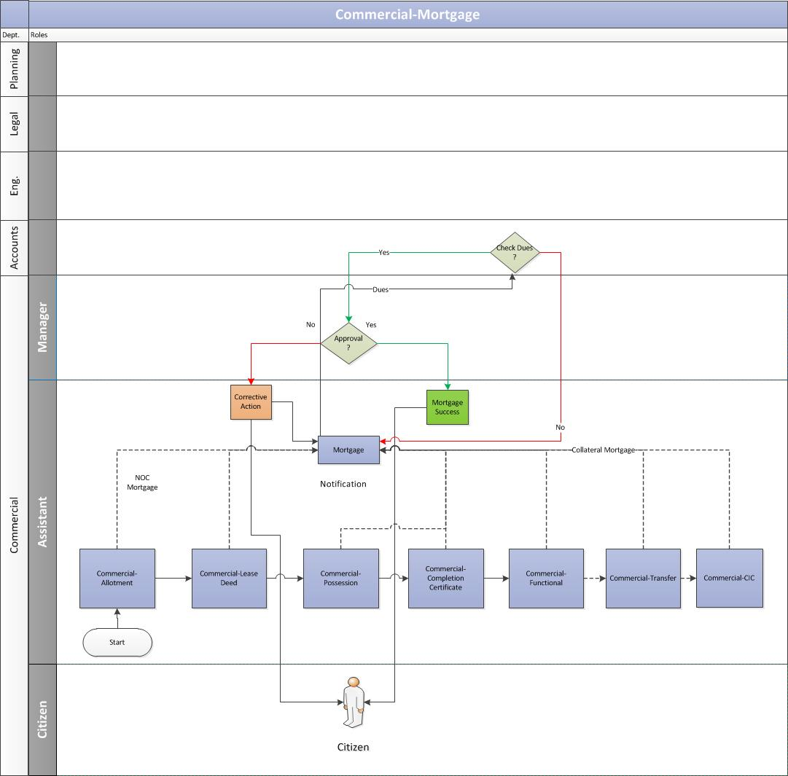

Customer submits the mortgage request
    - The allottee duly submits the mortgage request along with the required documents, for the construction or re-construction on the plot allotted, to the concerned department at Noida Authority.

Validation from Account department
    - The assistant receives the mortgage request and would send the same to account department to validate the allottee’s account details for any pending dues.
    - The account department would verify the allottee’s account details. In case of no pending dues, the account department would issue a No Dues certificate.

Approval from Manager
    - After receiving the confirmation from accounts, the assistant would send the mortgage request to the manager for his approval.

Mortgage Letter Issuance
    - Once the manager approves the mortgage request, the assistant would issue the Mortgage letter to the customer.
    - In case any previous mortgage exists, the assistant would notify the customer to clear the previous dues first before applying for fresh mortgage.

Business Rules for Mortgage
- Allottee of commercial plot/shops can mortgage the property after making full and final payment and upto date lease rent. The property can also be offered the allotted plot/shop as collateral security once full and final payment of the allotted plot/shop has been made and establishment been declared functional.
- The decision will be communicated within 7 days from the date of receipt of application complete in all respects.
- The request of mortgage can be processed in the following scenarios:
  - As soon as the lease deed is executed Or
  - Possession certificate is issued Or
  - Transfer of property.
- There are two types of the Mortgages:
  - Collateral Mortgage: The request of this mortgage is placed after the possession certificate is received and it is always taken against the allotted property once the full payment is made.
  - No Objection certificate (NOC) to Mortgage: The request of this mortgage is always requested after the allotment of the property and prior to lease deed execution.
- Permission for Mortgaging of premises as Collateral Security. Following are the requirements for mortgaging of premises as Collateral Security:

  - No dues certificate issued by the concerned Accounts Officer OR An undertaking by bank/institution for payment of the total dues directly to Noida.
  - A letter from bank/institution that the grant of loan is under consideration
  - No objection certificate from the respective co-operative society for mortgaging of residential plot allotted to the members of co-operative societies
  - No objection certificate from AWHO/AFNHB/Builders/Co-operative societies for the flats/houses allotted by the respective institution.
  - An affidavit on the prescribed proforma about unauthorized construction/use
  - A copy of the occupancy certificate/completion certificate for mortgaging residential premises and a copy of functional certificate for mortgaging commercial/commercial/commercial premises
  - Payment deposit challan in original for payment of Rs. 1,000/- (may change in future) in any of the authorized bank as processing charges
  - A copy of the resolution passed by Board of Directors/Executive Committee/Managing Trust if the allotment is in favour of a Company/Society/Trust
  - In case of allottee being a Partnership Firm, all partners shall be required to sign the application for Mortgage, alternatively the signatory partner has to produce an Authority Letter/Power of Attorney to move such an application

- Permission for Mortgaging of plot/premises to clear Noida's dues, raise construction, set up unit. Following are the requirements for mortgaging of premises:

  - No dues certificate issued by the concerned Accounts Officer OR An undertaking by bank/institution for payment of the total due amount directly to Noida
  - A letter from bank/institution that the grant of loan is under consideration
  - No objection certificate from the respective co-operative society for mortgaging of residential plot allotted to the members of co-operative societies
  - No objection certificate from AWHO/AFNHB/Builders/Co-operative societies for the flats/houses allotted by the respective institution.
  - An affidavit on the prescribed proforma about unauthorized construction/use
  - No charges/processing fee is payable.
  - A copy of the resolution passed by Board of Directors/Executive Committee/Managing Trust if the allotment is in favour of a Company/Society/Trust.
  - In case of allottee being a Partnership Firm, all partners shall be required to sign the application for Mortgage, alternatively the signatory partner has to produce an Authority Letter/Power of Attorney to move such an application.

Request for Change in Constitution (CIC/CIS/CIN/COD)

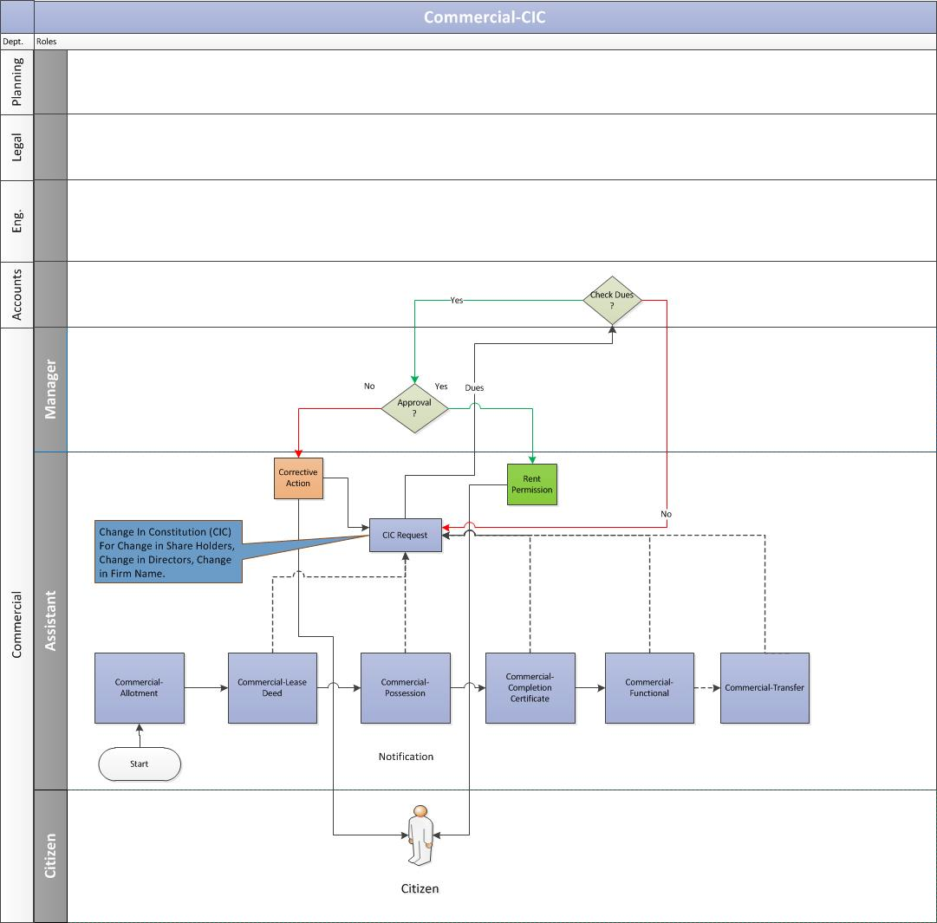

Customer submits application
    - The allottee duly submits the application along with CIC charges with required documents to the authority.

Validation from Account department
    - The assistant receives the CIC request and would send the same to account department to validate the allottee’s account details for any pending dues.
      - The account department would verify the allottee’s account details. In case of no pending dues, the account department would issue a No Dues certificate.
      - In case any previous dues exists, the assistant would notify the customer to clear the previous dues first before applying for the CIC letter.
    - Post verification from the accounts departments and if no dues exists, the assistant would ask the customer to pay the CIC charges.
    - The customer pays the CIC charges and updates the same to the authority.
    - The assistant verifies the CIC payment details with the accounts department.

Approval from manager
    - After receiving the payment confirmation from accounts, the assistant would send the CIC request to the manager for his approval.

CIC Letter Issuance
    - Once the manager approves the CIC request, the assistant would issue the CIC letter to the customer.

Business Rules for CIC
- Charges for change in constitution are in proportion of shares transferred. However, no charges are leviable in case incoming partner, or shareholder(s) are within blood relation i.e. father/ mother, husband/wife, son/daughter and vice-versa of the original allottee(s)/transferee(s). However, the original allottee(s) will maintain minimum of 25% shareholding in the company/firm for a stipulated number of years.
- No CIC charges are applicable for 100% transfer of shareholding within blood relation i.e. father/ mother, husband/wife, son/daughter and vice-versa of the original allottee(s)/transferee(s). However, processing fee of Rs.1,000/- (may change in future) is payable along with request for the same.
- Change in constitution after execution of lease deed and taking over possession would be considered with respect to original allottee(s)/ transferee(s) only. It is mandatory for the original allottee(s)/ transferee(s) to retain minimum of 25% shareholding in that company/ firm in whose favour the change in constitution is sought.
- No CIC charges are levied if the CIC is in favor of Public Ltd. Co. then there would be a minimum requirement of shareholding with the original allottee(s)/transferee(s) and any subsequent change in shareholding would be without charges.
- In case the allottee/transferee is a incorporated company and subsequently a partnership firm or another incorporated company is formed with the original incorporated company as a partner/shareholder then the CIC charges would be applicable on the percentage of shareholding not held by original allottee(s)/transferee(s), company. In case other partner(s)/shareholder(s) are the shareholders of the original company then no CIC charges would be leviable.
- In case where 100% CIC charges are levied, such cases would be treated at par with transfer cases.
- No CIC charges would be levied in case an original partner(s)/shareholder(s) withdraws from the partnership firm/incorporated Company.

Request for Rent Permission
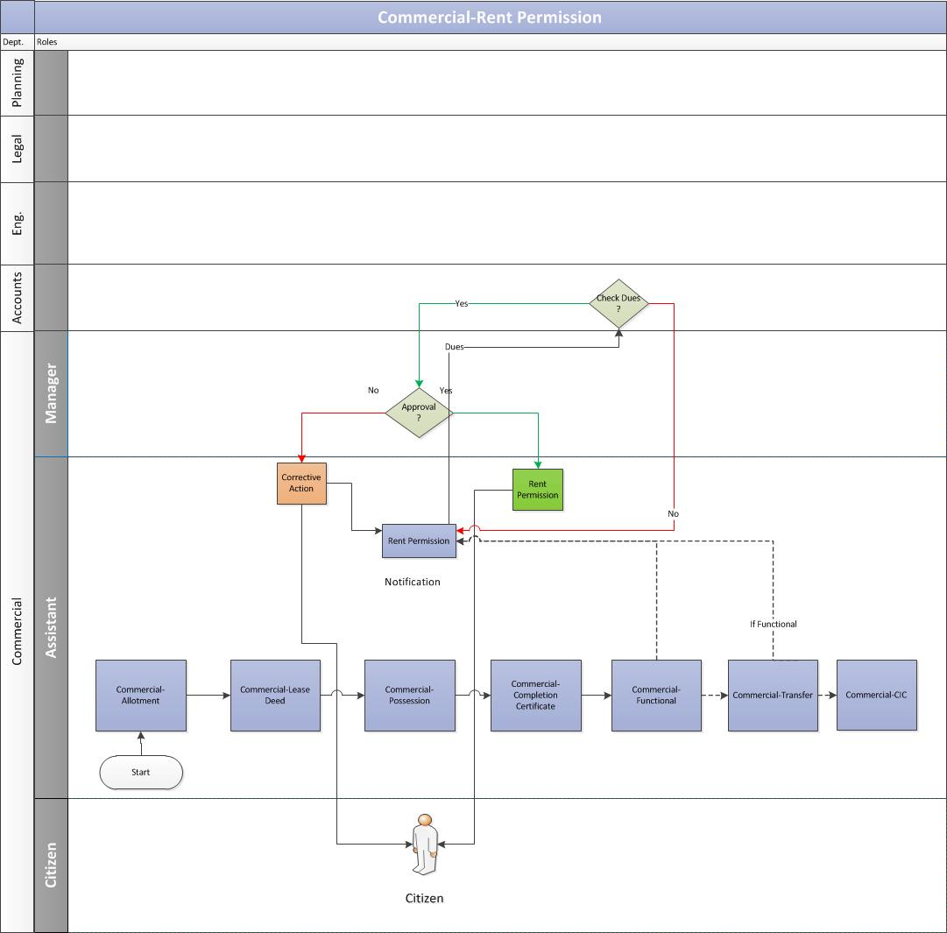

Customer submits application
    - The allottee duly submits the application along with the rent permission charges with required documents to the authority.

Validation from Account department
    - The assistant receives the rent permission request and would send the same to account department to validate the allottee’s account details for any pending dues.
      - The account department would verify the allottee’s account details. In case of no pending dues, the account department would issue a No Dues certificate.
      - In case any previous dues exists, the assistant would notify the customer to clear the previous dues first before applying for the rent permission letter.

    - Post verification from the accounts departments and if no dues exists, the assistant would ask the customer to pay the rent permission charges.
    - The customer pays the rent permission charges and updates the same to the authority.
    - The assistant verifies the rent payment details with the accounts department.

Approval from manager
    - After receiving the payment confirmation from accounts, the assistant would send the rent permission request to the manager for his approval.
    - Once the manager approves the request, the assistant would issue the rent permission letter to the customer.

Request for Sublease
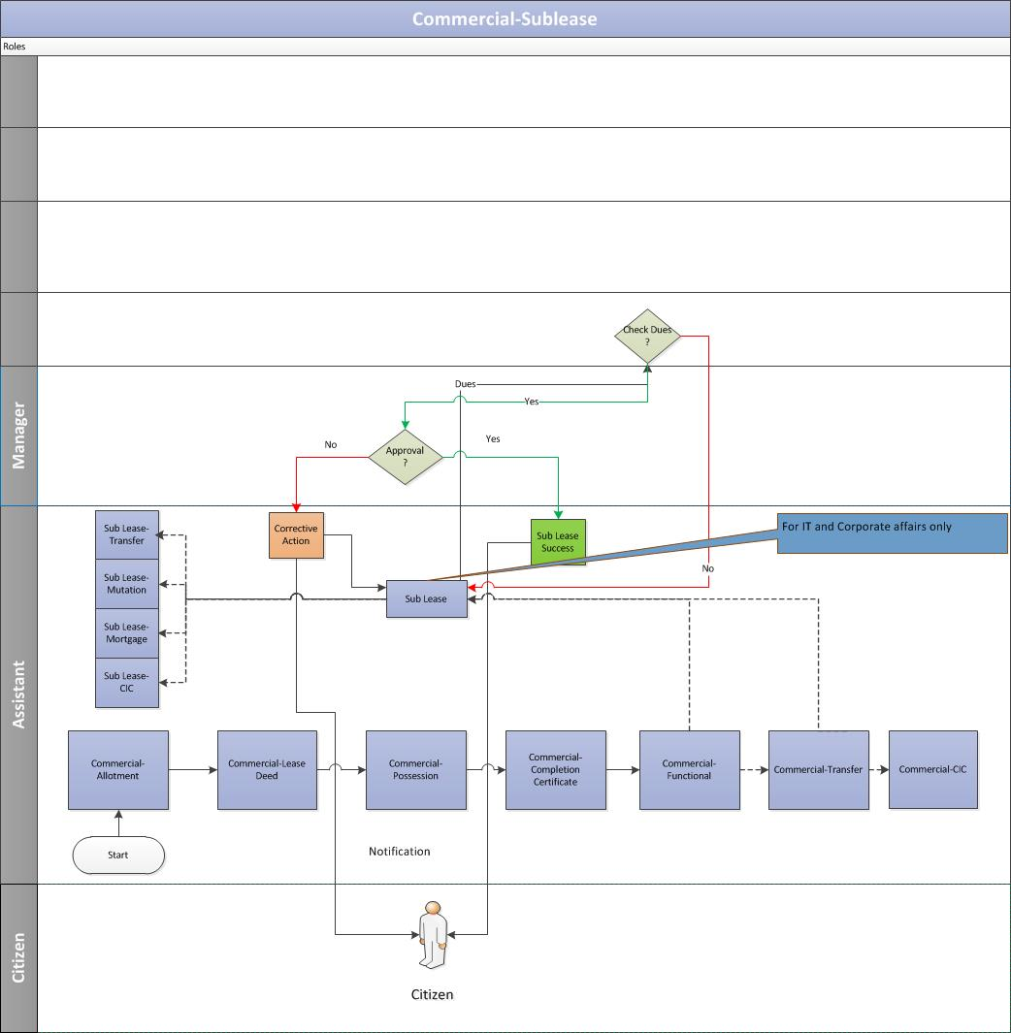

Customer submits application
    - The allottee duly submits the application along with sublease charges with required documents to the authority.

Validation from Account department
    - The assistant receives the sublease request and would send the same to account department to validate the allottee’s account details for any pending dues.
      - The account department would verify the allottee’s account details. In case of no pending dues, the account department would issue a No Dues certificate.
      - In case any previous dues exists, the assistant would notify the customer to clear the previous dues first before applying for the sublease.
    - Post verification from the accounts departments and if no dues exists, the assistant would ask the customer to pay the sublease charges.

Approval from manager
    - After receiving the payment confirmation from accounts, the assistant would send the sublease request to the manager for his approval.
    - Once the manager approves the sublease request, the assistant would issue the sublease letter to the customer.

Business Rules for Sublease
- The property should be functional in order to issue the sub lease for the property.
- The Sub-lease is only done for the IT and corporate affairs post receiving the functional letter.
- There is a provision under sub-lease to get the following request processed: Sub Lease Transfer, Sub Lease Mortgage and Sub Lease Mutation after Death.

Payment Schedule Logic for Commercial Department

Payment Schedule Formulae
The calculation of the payment schedule for Institutions would be done using Reducing Monthly Installments. The formula for the same is as follows:

Total Premium Balance Amount = Total Cost of property – (allotment money + earnest money)

Principal Amount= Total Premium Balance Amount/No. of Installments

The first installment in reducing monthly installment method can be calculated as:

First Installment Interest Calculation = [Total Premium Balance Amount * (Rate of Interest/Frequency)]/100

Premium Balance Amount = Premium Balance Amount - First Installment Principal Amount

From First Installment Interest onwards,
Second Installment Interest Calculation = [Balance Premium Amount *(Rate of interest/Frequency)]/100

Premium Balance Amount = Premium Balance Amount - Second Installment Principal Amount
Similarly,
Nth Installment Interest Calculation = [Balance Premium Amount *(Rate of Interest/Frequency)]/100

Premium Balance Amount = Premium Balance Amount - nth Installment Principal Amount

Payment Schedule Example
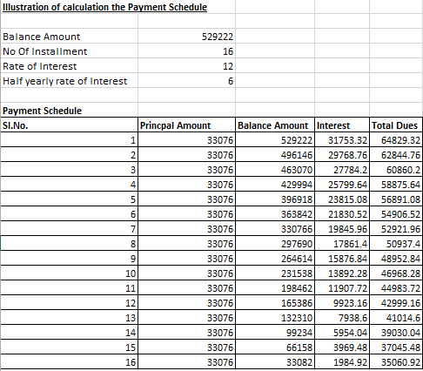

Dues Calculation

Example 1 - Part Payment Calculation
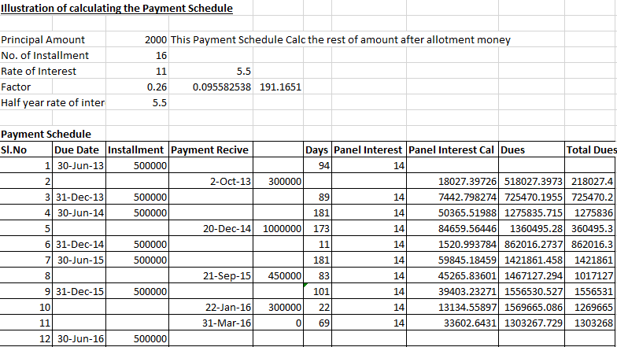

Example 2 – All Payments Outstanding Calculation

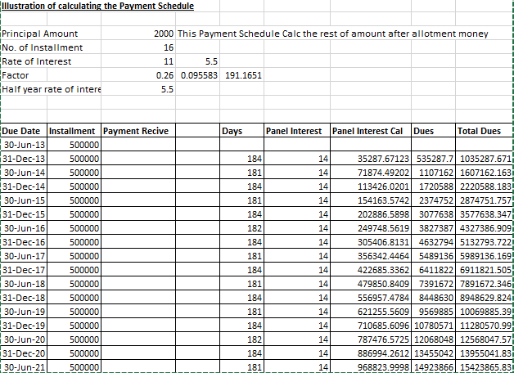

Note:
  - For the first six months (from 1st January to 30th June), the number of days for calculating the daily interest would be 181 days. In the case of leap year, the number of days for calculating the daily interest would be 182 days.

  - For the last six months (from 1st July to 31st December), the number of days for calculating the daily interest would be 183 days.

  - The panel interest will be applicable if the payments are defaulted.

  - If a person defaults, then penal interest would be applied to his outstanding payment. Penal interest can be calculated as

p*(1+r/100)^n

where, P = Principal
r = rate of interest
n = frequency

Miscellaneous
It is mandatory to get the lease deed executed for property after allotment is made within a stipulated time-frame (Currently 30 days).
Post that, penalties will be levied on the citizen based on the below formula:
Penalties = [(One Year Lease Rent)/365) * no of default days +one year lease rent]

Note: After every 10 years lease rent will be revised.

